NCDOT MVBA Applications

- CellCounter – Provides coordinates and count of specified cells in a dgn file. A report is written to an Excel spreadsheet. Also provides Geopak Adhoc attributes if any are attached to the cells.

Keyin to run: vba run [cellinfo]analyze_cell

The target cells to count are provided by a selection set, or the application will provide a list box of all cells found in the drawing. Either way, the list eliminates duplicate cell listing. If a selection set is not available when the application is run, a dialog box lists the available cells. Select the cell(s) desired (use <shift> or <control> to select multiple cells, then press the “Begin” button. A spreadsheet will be created providing columns for Northing (X) Easting (Y) Elevation (Z) and adhoc attributes. A count of the specified cell follows the listing.

Press the “Cancel” button to abort the run.

- All_Levels_On – Turns on all levels in active file and all reference files.

Keyin to run: vba run [all_levels_on]levels_on

Turns on all levels in active file and all attached references.

- Level_Overrides_Off – Allows toggling of level overrides (level symbology) for the active file and/or selected reference files. Can toggle color, style, or weight overrides independently.

Keyin to run: vba run [level_overrides_off]main

This application opens a dialog box with check boxes to select display of Color, Style and Weight overrides. If a box is checked, that override will be applied, and whatever symbology has been set for that override will be in effect. The user has the option of applying the override to the active file and also selected reference files. There is also a check box to toggle the display of overrides. If unchecked, no overrides will be displayed. The “Clear List” button is used to clear any selected reference files. After setting the desired parameters, press the “Apply” button. Press “Cancel” to close the application.

NOTE: When a reference file or the active file is selected, the state of the overrides check boxes (i.e. whether the color, style, or weight boxes are checked) determines whether the associated override is applied or removed.
The configuration variable MS_LEVEL_EDIT_ATTRIBUTE_LIST must be set to OverrideSymbology for this to work.

- OffBySelection – Turn off levels determined by picking elements. Also controls level display in selected reference files.

Keyin to run: vba run [offbyselection]main

A dialog box lets the user select reference files to apply the display to, and whether to include the active file. The user selects elements to determine levels to not display, then presses the “Apply” button. The “Clear List” button will reset the list of reference files, and the “Cancel” button closes the application. Subsequent uses of the application will turn off the display of additional levels without changing the existing display.

NOTE: A data point must be issued to accept each selected element. This data point can also select subsequent elements, but you must remember to issue a final data point to accept the last element chosen. When choosing an element in a cell, only the level of the chosen element will be affected, but the ENTIRE CELL will highlight.

- OffExceptSelection – Turn off all levels except those levels determined by picking elements. Also controls level display in selected reference files.

Keyin to run: vba run [offexceptselection]main

A dialog box lets the user select reference files to apply the display to, and whether to include the active file. The user selects elements to determine levels to maintain display, then presses the “Apply” button. The “Clear List” button will reset the list of reference files, and the “Cancel” button closes the application. Subsequent uses of the application will affect the existing display.

NOTE: A data point must be issued to accept each selected element. This data point can also select subsequent elements, but you must remember to issue a final data point to accept the last element chosen. When choosing an element in a cell, only the level of the chosen element will be affected, but the ENTIRE CELL will highlight.

- Show_Elements_Symbology – Reports the fixed attribute symbology, the ByLevel symbology, or the Override symbology of a selected element.

Keyin to run: vba run [show_elements_symbology]main

When an element is chosen, a dialog box reports the following:

If the element uses element symbology:
Element Color Is:
Element Linestyle Is:
Element Weight Is:

If the element uses ByLevel symbology:
ByLevel Color Is:
ByLevel Linestyle Is:
ByLevel Weight Is:

If Level Symbology (Overrides) is on:
Level Symbology Element Color Is:
Level Symbology Element Linestyle Is:
Level Symbology Element Weight Is:

NOTE: A selection set cannot be used with this tool.

- Show_View_Rotation – Reports the angle by which a view has been rotated.

Keyin: vba run [show_view_rotation]showrotation

A dialog shows the rotation angle of the view. If multiple views are open, the view that received the last data point or tentative point is the view that gets reported on.

- Show_WS_User – Reports the current workspace.

Keyin to run: vba run [show_ws_user]configvars

A dialog shows the current workspace user (i.e. Hydraulics, Location, Roadway, etc.)

- Zoom2Selected – Windows a user selected view around elements placed in a selection set or a fence.

Keyin to run: vba run [zoom2selected]main

A selection set or fence must be in place before this application will run.
A dialog opens so the user can select the view window in which to display the element (default is view 4) and a button to display the First element, the Next element, or to cancel and close the dialog.

If a fence was used to select the desired elements, the Element Information dialog box also opens so information can be obtained about the elements.

- Adjust_Level_Overrides – Allows toggling on or off level overrrides in master file and references. Also allows selecting color and weight to be used as override symbology.

Keyin to run: vba run [adjust_level_overrides]main

This mvba runs like Level_Overrides_Off but has the additional capability of allowing the user to choose a color and weight to be applied as the override attribute for the master file and/or chosen references.

- Attach State Raster Tiles –

Keyin to run: vba run start.main

Due to the NC OneMap service being down more than we would like, there is now a convenient alternative to attaching aerial imagery that relies upon our own NCDOT Servers. This alternate method only attaches imagery you specify which may help reduce MicroStation View refresh times as compared to NC OneMap, since it has to refresh the entire state. To access this new tool, please ensure you have both NCDOT_Stds and NCDOT_V8_CONFIG workspaces up to date. Once your workspaces are up to date, below is how to use the new (alternative) tool:

Open MicroStation and click on the NCDOT menu as shown below and select “Attach State Raster Tiles.”

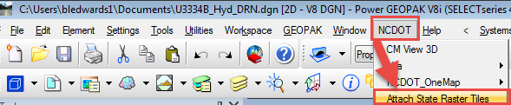

Next follow the steps shown below:

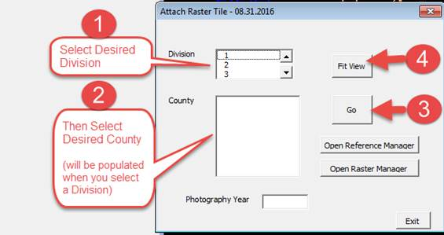

Then click on the desired tile number and accept with a data click. This should bring up the image for that tile.

