North Carolina Department of Transportation
Division of Highways

QUARRY MAP PROGRAM

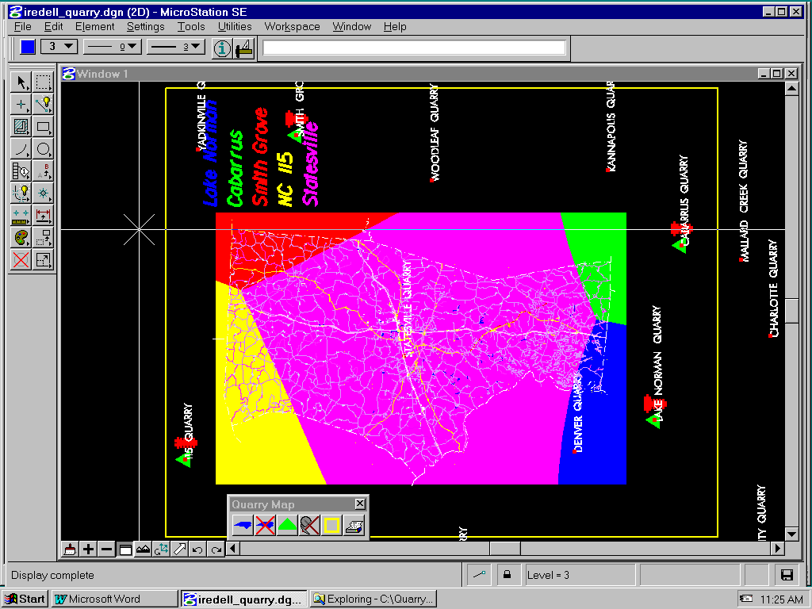

Developed by Engineering Technology Systems
March 1999
QUARRY MAPs

Purpose
The Quarry map program is used to generate a color-coded map of the equal cost haul contours for each quarry that bids on materials within a county. This program will generate and plot the color-coded maps and print the mileage calculations that are to be furnished to the Purchasing Section along with the material requisition. The quarry map program will alleviate division personnel from having to calculate the equal cost mileage and hand drawing the color-coded map.

Overview
In order for the program to work correctly the user must download from the ftp sites a quarry map seed file, a quarry map location file, and the county map file for which the contours are being generated. Once these files are downloaded to the local PC, using MicroStation, the files should be referenced to one another and then the Quarry Map program executed.
The program requires the user to locate the quarry, enter the quarry name, and enter a bid price of each material. Once this information is completed the program will compute the equal cost contours and the mileage calculations for each quarry. The equal cost contours are drawn over the county map and color-coded to represent the least cost area for each quarry. The contours for each material bid on is drawn on a different MicroStation level such that levels may be turned on or off to generate maps for each of the different materials. The maps may then be plotted, the mileage calculation printed, and attached to the material requisition.
Once the files are downloaded and referenced the same files will be used for several years. For the next material requisition period the material prices for each quarry may be updated, any new quarries added, and new quarry maps generated.

Limitations
The county maps will not contain any text, such as the interstate, US, and SR route numbers and street names, only the line work representing the highways in the county.
Instructions

1. Reload the NCDOT workspace on the PC.
By reloading the NCDOT workspace the mdl application and all the files necessary for the program to work correctly will be stored in the proper location.

2. Create a directory structure for the Quarry Map information.
Since the same maps and quarry locations will be used for several years it is important to be able to easily locate the quarry information. For this reason the following folder structure is recommended. The Folder structure may be created on any drive but all illustrations will use the ‘C’ drive. The terms ‘Directory’ and ‘Folder’ are used interchangeably.
A. Create a top-level folder named “QuarryMaps”.
B. Create a sub-folder under the QuarryMaps folder for each county in the
division. (ie. Wake, Durham, Franklin, etc. for Division 5)
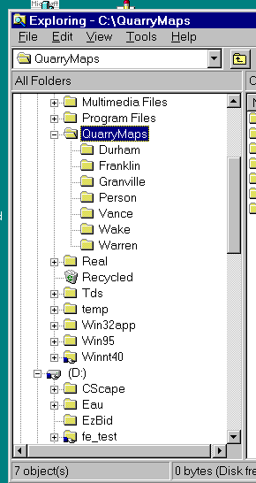
3. Transfer the quarry location map and seed files.
The MicroStation Quarry Map seed file and the quarry location design file are located on Engineering Technology System’s ftp site. These files must be transferred to the local PC and they must be located in the correct folder in order for the mdl application to work correctly.
A. Start WS_FTP. Double-click the icon on the desktop –or-- use the start menu and select START->PROGRAMS->WS_FTP.
B. Connect to the DOH ftp site using the following information
Host Name: ftp.doh.dot.state.nc.us
Host Type: automatic detect
User ID: anonymous
Password: e-mail address -----or----- “guest”
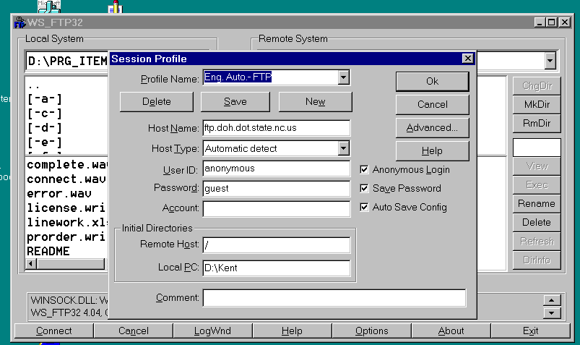
Leave all other entries blank. The anonymous login box may be checked and
used for anonymous logins to the ftp site.
C. Click the OK button.
D. Once the connection is established, on the Local System side of the FTP
dialog box change the active folder to “C:\QuarryMaps”. On the Remote
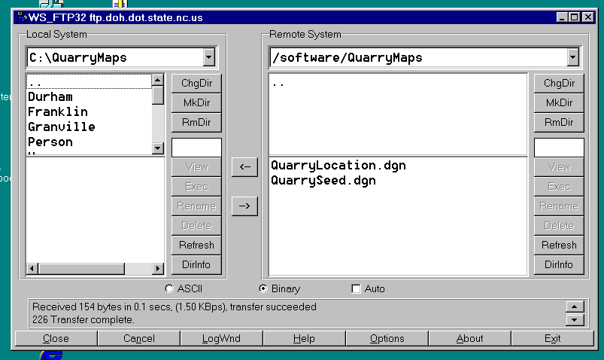
System side of the dialog change the active folder to “\software\QuarryMaps”
E. Download the following files: “QuarrySeed.dgn”, and QuarryLocation.dgn”.
These files should be transferred from the \software\QuarryMaps\ folder on
the ftp server and placed in the C:\QuarryMaps folder of the local PC.
F. Exit the connection to the ftp site by selecting the EXIT button.

3. Transfer the county map files.
The county map file for each county should be transferred to the sub-folder created for
that county.
A. Start WS_FTP. Double-click the icon on the desktop –or-- use the start menu
and select START->PROGRAMS->WS_FTP.
B. Connect to the GIS ftp site using the following information
Host Name: gissrv1
Host Type: automatic detect
User ID: anonymous
Password: e-mail address -----or----- “guest”
Leave all other entries blank. The anonymous login box may be checked and
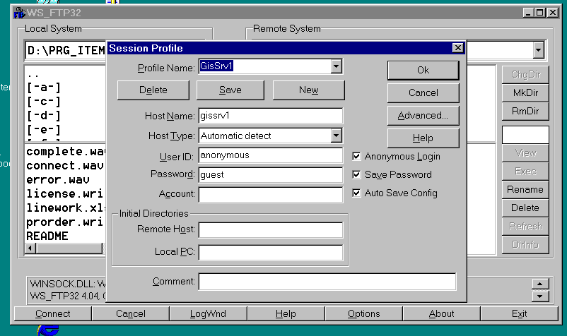
used for anonymous logins to the ftp site.

C. Click the OK button.
D. Once the connection is established, on the Local System side of the FTP
dialog box change the active folder to “C:\QuarryMaps\CountyName” where
CountyName is the County for which the map is being transferred.
Example, for Nash county the local folder would be “C:\QuarryMaps\Nash”.
On the Remote System side of the dialog change the active folder to the
appropriate division and county “\divX\CountyName” where divX is the
division number and CountyName is the county for which the county map is
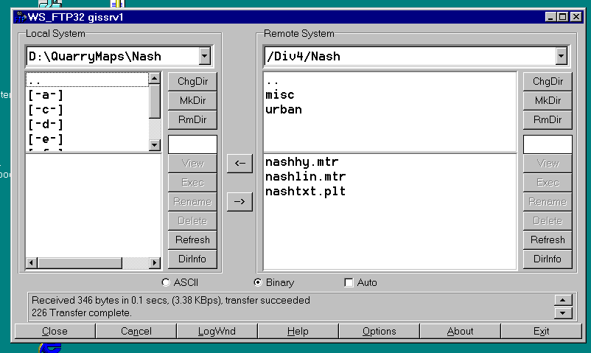
needed. Example for Nash County the folder would be “\div4\nash”.

E. Download the file containing the county’s highway line work. This file name
will have the format “xxxxlin.mtr” where the xxxx represents the first four
characters of the county name. The line work file name for Nash county
would be nashlin.mtr, Cleveland county would be “clevlin.mtr”.
F. Once the highway line work file is transferred exit the connection to the ftp
site by selecting the EXIT button.

4. Copy and Rename the Seed File for each County.
Once all files have been downloaded from the appropriate FTP sites, the
QuarrySeed.dgn file must be copied to each county folder and renamed for that
county. It is suggested that the file be name xxxx_Quarry.dgn where xxxx is the
complete county name. Example for Iredell county the suggested file name would be
Iredell_Quarry.dgn.

5. Start MicroStation opening the county seed file.
Using the renamed xxxx_Quarry.dgn (copied and renamed in step 4) file start MicroStation. This is a blank design file, no element will be displayed on the screen when this file is opened.
6. Attach the appropriate reference files to the xxxx_Quarry.dgn file.
Using the MicroStation reference file commands (FILE->REFERENCE-TOOLS->
ATTACH) attach the “xxxxlin.mtr” file, this file contains the highway line work for
the county and should be located in the current folder (C:\QuarryMaps\countyName).
The second reference file to attach is the QuarryLocation.dgn file from the
C:\QuarryMaps” folder. Both these file should be attached coincidentally and the
Save Full Path box should be checked. Once these two reference files are attached, do
not dismiss the reference file dialog box until instructed to do so.

7. Set the Files Update Sequence.
Next select the Update Sequence command from the Reference Files Dialog box
(SETTINGS->UPDATE SEQUENCE). Set the update sequence for the file as
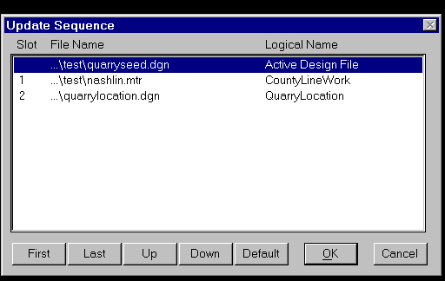
follows:

Active design file should update first, the county line work file (xxxxlin.mtr) second, and the quarry location file (QuarryLocation.dgn) should be the last file in the update sequence.

This update sequence makes the county line work and quarry locations visible after the filled shapes are created and displayed later in the process.

8. Turning off levels in the line work Reference File.

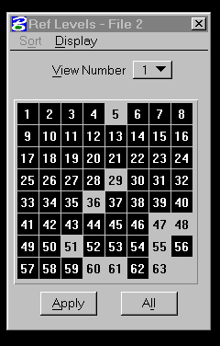
Once all the reference files are attached certain levels in the line work file should be turned off. First highlight the county line work file (xxxxlin.mtr) in the Reference File Dialog box. Next from the menubar select the SETTINGS->LEVELS command and the Ref Levels dialog will appear on the screen. Turn off levels 5, 29, 36, 47, 48, 51, 55, 60, 61, and 63. This will remove certain borders and other line work that is not needed for the quarry map. Dismiss the Ref Levels dialog box by clicking on the small ‘x’ in the upper right corner.

9. Set the level symbology in the line work Reference File.
To make the color-coded quarry map more readable the line weights in the county
line work file (xxxxlin.mtr) should be overridden with weight 0 lines. This is done by
using Reference File Level Symbology.

A. Select FILE->REFERENCE from the MicroStation menu bar. The reference file
dialog box should appear.
B. Select and Highlight the county line work file xxxxlin.mtr.
C. From the reference file dialog box’s menu bar select SETTING->LEVEL
SYMBOLOGY.
D. The ref level symbology dialog will now appear.
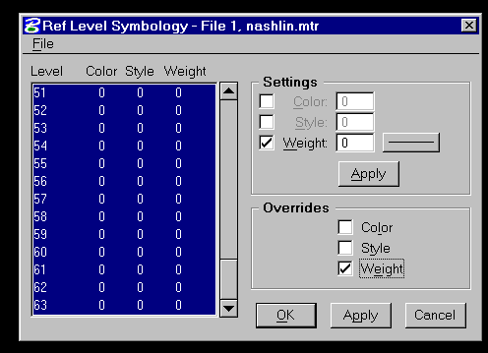
On the left pane of the dialog select all levels by
holding down the SHIFT key and left clicking the
mouse on level 1. While still holding down the
SHIFT key pull the right slide bar down until
level 63 is seen. Still holding down the SHIFT
key left click the mouse on level 63. All levels
in the left pane should highlight.
E. In the upper right pane of the dialog, titled
SETTINGS, check the box next to WEIGHT and
then set the weight value to 0. Next left click the
APPLY button and all weights in the left pane of
the dialog should reset to a value of 0.
F. In the lower right pane of the dialog, titled
OVERRIDES, check the box next to WEIGHT and then left click the APPLY
button.
G. Next left click the OK button and the ref level symbology dialog box should be
dismissed.

10. Dismiss the Reference File Dialog box.
Left click the mouse on the small ‘x’ located in the upper right corner of the dialog
box.

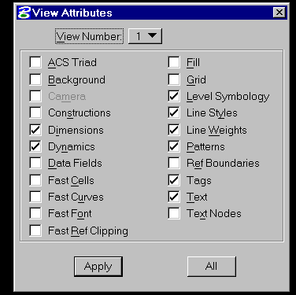

11. Next update the view and all line weights in the county
line work file should display as weight 0. If line weights
are still displayed check the level symbology setting in the
View Attributes dialog box. The “Level Symbology” box
should be checked.

12. If the county line work file and quarry locations are not visible on the screen
select the Fit View command. Once the line work and quarry locations are displayed
use the Window Area command to situate the county on the screen.

13. Save the design file settings.
From the MicroStation menubar select FILE->SAVE SETTINGS. If the ‘save setting
on exit’ option is set for this workspace the SAVE SETTINGS command will be
grayed out and this instruction may be skipped.

At this point the xxxx_Quarry.dgn design file should display the highway line work for the county and the locations of all previously located material quarries in the state. All the previously located material quarries have the quarry name displayed adjacent to a small red square indicating their location. The previously described instructions have set up the quarry map for a particular county. If these design files are not deleted from the hard drive they may be used to develop quarry maps for several years without having to repeat the preceding process.

The next series of steps describe how to use the quarry map program to generate the color-coded maps. Use the following instructions each time a new quarry map for a material is needed for the purchase requisition. The general order of work will be to identify the quarry location, enter the price of the active material, generate a color-coded quarry map, and then plot the quarry map. If the quarry locations have been previously identified the prices of the material may be changed and a new quarry map generated and plotted without having to locate the quarries again.

STARTING THE QUARRYMAP PROGRAM
(QuarryMap.ma)
The QuarryMap program is a MicroStation mdl application that must be run in conjunction with an open MicroStation design file. The correct version of the NCDOT workspace must be loaded on the PC in order for the QuarryMap mdl application to be available for use.
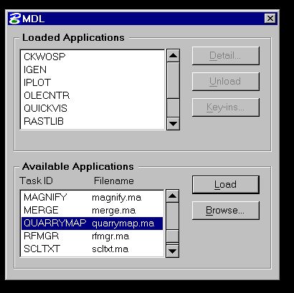
Begin the QuarryMap mdl program by selecting the UTILITIES->MDL APPLICATIONS command from the MicroStation menubar. An MDL dialog box opens, from the lower pane of the dialog titled Available Applications select the QuarryMap.ma mdl application. Next left mouse click on the LOAD button.

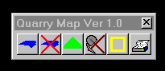
The MDL dialog box can be dismissed by left clicking the mouse on the small ‘x’ in the upper right corner. If the message “QUARRY MAP already loaded” appears at the bottom of the screen, the QuarryMap application can be started by keying QUARRY in the key-in box. In either event, the QUARRY MAP tool bar will appear on the screen, ready for use.

There are six buttons on the quarry map tool bar and each button performs a function
with the end result being a plotted color-coded quarry map. The six buttons are identified as PLACE MAP, REMOVE ACTIVE MAPPING, PLACE QUARRY, EDIT QUARRY, PLACE BORDER, and SEND TO PLOTTER. Before detail instructions are given for each button on the tool bar, the concept of an active material should be explained.

Active Material
A separate color-coded quarry map will be developed for each material type ie.
78M, #6 Stone, ABC aggr., Class A stone, and Class B stone. To accomplish this, set one of these materials as being the ACTIVE MATERIAL. Once the active material is set any material prices entered or quarry maps generated will be for the active material only. As the user changes the active material and enters the prices, a color-coded map may be generated showing the cost contours for the active material. The active material concept allows a quarry to be located once and then material prices entered for any or all of the materials supplied by that quarry. It also allows the same county mapping and quarry locations map to be used for all materials. This is done by drawing the quarry maps for each material on a separate design file level and then turning the level on or off depending on the active material. When the color-coded quarry map is drawn, it will be generated for the active material on the correct level. By changing the active material a quarry map for each material may be drawn in and plotted from the same set of design files.
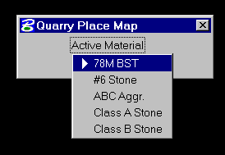
With the exception of the create border button, the Active Material may be set as a part of the operation of any button selected from the Quarry Map tool bar. In all cases the active material is set in the same manner. When a tool bar button is selected a dialog box will be displayed on the screen. The title on the dialog box will display the function being performed. Near the top of the dialog will appear an Active Material button. On the face of this button the current active material is displayed. If this is the correct active material do nothing. To change the active material, left mouse click on the active material button and a material list will drop down. To set the Active Material, left mouse click on a material in the list. The last material selected from any tool bar operation is always the Active Material and will display on the face of the active material button.
LOCATING A QUARRY (Place Quarry)
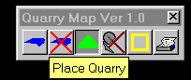
The first step toward generating the color-coded quarry map is to identify the location of the quarries and enter the prices for the material. For the user’s convenience a quarry location map (QuarryLocation.dgn) is downloaded and referenced to the active design file. This file contains the location and name of most of the qualified quarries in the state. Even when the name of the quarry that bid on the active material is displayed on the map, the user must locate it with the PLACE QUARRY command. The location and bid prices will be registered with the QuarryMap program. If the location for a quarry is not shown in the QuarryLocation.dgn file, the user must use the county map line work to locate the quarry as accurately as possible. Since there are no US or SR route numbers on the county maps this may be difficult, but it is extremely important the quarry be located as accurately as possible. Incorrect location of a quarry will cause the map to compute bad equal cost contours. To begin the quarry location process, left mouse click on the third button
(Place Quarry) of the quarry map tool bar.

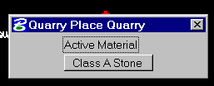
A dialog titled PLACE QUARRY will appear and the MicroStation prompt (bottom of screen) will read PLACE QUARRY>SELECT POINT FOR PLACEMENT.

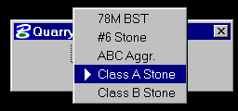
In the dialog there will be the Active Material button. If the material type displayed on the face of this button is not correct, left mouse click on the button and the drop-down material list will appear. Left mouse click on the correct material and this material type will display on the face of the button. The correct material type must be set as the Active Material (displayed on the button face) before the data point for the quarry location is issued.

The next step is to identify the location of the quarry. If the quarry location is designated in the QuarryLocation.dgn file, do a tentative data point to the small red dot located closest to the quarry name, then data point to identify the location point.
If the quarry location does not appear in the QuarryLocation.dgn file it must be manually located. Using the county mapping, locate the highway along which the quarry is located. Then locate the quarry as accurately as possible. This may be somewhat difficult since there are no US or SR route numbers on the mapping. The use of a printed county map may help in this process. When the quarry location is established enter a data point. When the data point is entered the program will place a shared cell named QUARRY at the data point location.

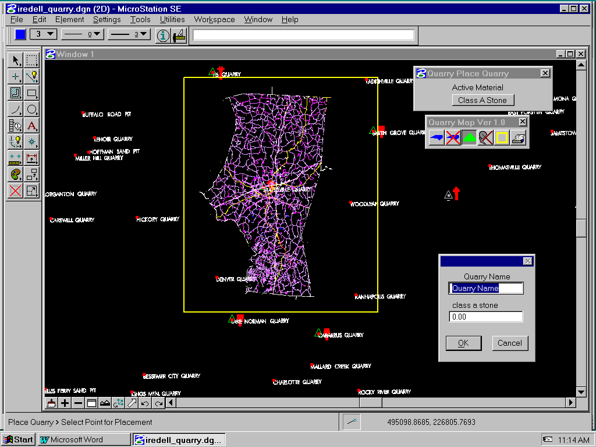
Once a data point is issued for the quarry location another dialog box will display. This dialog is used to enter the Quarry Name and the price of the active material. Key-in the price of the active material, then tab to the quarry name field and enter to the name. The active material type is displayed in the dialog but it can not be changed. Once the quarry name and active material price have been entered correctly, click on the OK button and the name and price are stored along with the location of the quarry. The material price may be omitted and entered later using the EDIT QUARRY tool. When a quarry location is identified the program makes allowances to store the price of all the various material types, even thou only the active material price is entered. All other materials are stored with $0.00 prices. Later the EDIT QUARRY tool may be used to enter prices for material stored with a $0.00 value. This allows the program to keep track of the quarry, its location, and the price of each material.
Once the OK button is clicked the name and price dialog disappears and the application recycles ready for the next quarry data point, quarry name and price information. The sequence of location data points, quarry names and price information may be continued until the user has entered all the quarries for a county.
If another quarry is to be entered at a later time the user should again select the PLACE QUARRY tool and enter the name and material price. If a quarry is place at an incorrect location it must be deleted using the MicroStation DELETE command and entered at the correct location using the PLACE QUARRY tool.

ADDING or CHANGING QUARRY INFORMATION (Edit Quarry)

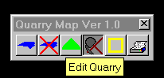
Once a quarry has been identified and located it may be necessary to change the quarry name, and modify or add a material price. All changes or additions to the quarry information are handled through the EDIT QUARRY tool. Select the EDIT QUARRY tool by left clicking the mouse on the fourth button on the QUARRY MAP tool bar (pick and shovel). Once this tool is select the QUARRY EDIT dialog box appears. If the quarry is to be removed from the equal cost contour calculations, use the MicroStation DELETE ELEMENT command and delete the quarry cell or set the price of the active material for this quarry to $0.00. Any quarry encountered with a $0.00 price will NOT be used in equal cost contour calculations.

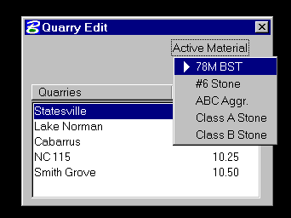
The QUARRY EDIT dialog will display all the previously located quarries and the prices of the active material for each quarry. In the top portion of the dialog is the ACTIVE MATERIAL button. This button may be used to set the active material. By setting the active material the user may review or change the prices of the various materials. If the material type displayed on the face of this button is to be changed, left mouse click on the button and the drop-down material list will appear. Left mouse click on the material and this material type will display on the face of the button.
The lower portion of the dialog will then update to reflect the prices of the new active material. The correct material type must be set as the Active Material (displayed on the button face) before the prices will update. Once the active material is set correctly, double-click the left mouse button on the quarry to be changed
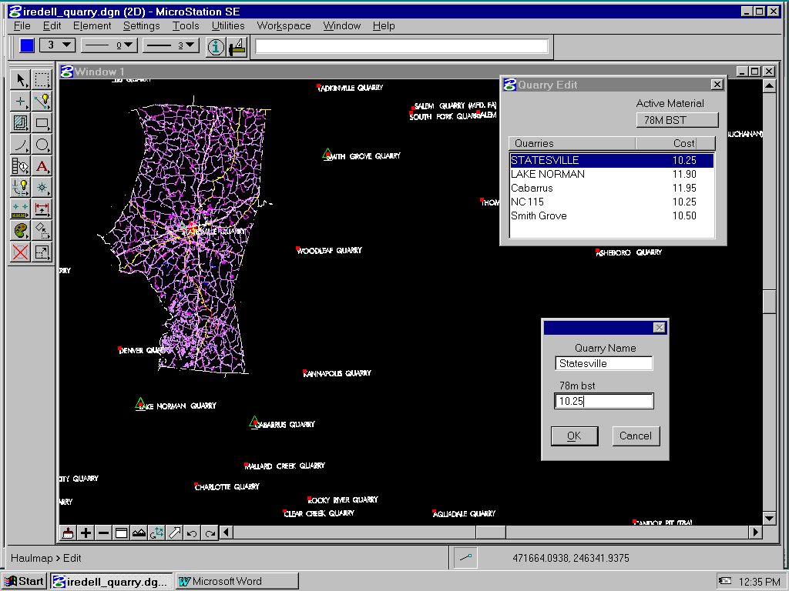
A dialog box will appear displaying the quarry name and the price of the active material. By highlighting and over typing the existing value, the quarry name (not location) and/or the active material price may be changed. Once the changes have been completed click the OK button and the changes are saved and reflect in the Quarry Edit dialog. Click the CANCEL button and any changes made in the dialog are discarded. In either event, the QUARRY EDIT dialog again becomes the active dialog box. By double clicking another quarry or resetting the active material, other information can be modified.
By changing the material bid price to $0.00 this quarry will be excluded in the equal cost contour generation. Once all the modifications are made, the QUARRY EDIT dialog box may be dismissed by left mouse clicking on the small ‘x’ in the upper right corner of the dialog or by selecting another tool from the QUARRY MAP tool box.

PLACING THE BORDER (Place Border)

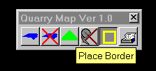
The purpose of the PLACE BORDER tool is two fold. First it determines the point at which the equal cost contours will end and secondly, when a plot is requested, it will determine the area of the design file to be plotted. When an equal cost contour intersects the border, the program will stop the contour line. If an attempt is made to generate equal cost haul contours without having placed a border in the design file an error message will display. Secondly when plotting the color-coded map the border will define the area to be plotted. If any information, such as a legend, is added to the map it must be within the border if it is to be plotted. It is acceptable to enter notes outside the border. If no border is present when a plot is requested, an error message will appear and a border must be entered before the SEND TO PLOTTER tool is used. The border may be altered between the equal cost contour generation and the plot request, however the border displayed at plot time will define the plot area.
To create a border left click on the fifth button in the QUARRY MAP tool box (Place Border). Next data point the corner at which the border is to begin and then issue a second data point at the opposite corner. The border will display as a shape with the following symbology, color = yellow , weight = 1 and level = 40.
If there is an existing border in the design file it will be automatically deleted and replaced by the new border.

GENERATING COLOR-CODED MAP (Place Map)

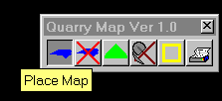
Once the quarries are located, the prices for a material entered for each quarry bid, and a border placed, the user is ready to generate the equal cost contours (color-coded map). To begin generating the equal cost contour click on the first button (PLACE MAP) on the Quarry Map tool bar.
Once the Place Map tool is selected the user is given the opportunity to set the active material. If the material type displayed on the face of this button is not correct, left mouse click on the button and the drop-down material list will appear. Left mouse click on the correct material and this material type will display on the face of the button. The correct material must be set as the Active Material (displayed on the button face) to generate the color-coded map for a particular material.
The MicroStation prompt (bottom of screen) will now read PLACE MAP>SELECT VIEW. By placing a data point in the view, the mdl program will generate the equal cost haul contours. If there are existing equal cost contours for this material type they will be automatically deleted and new contours generated based on the current material prices. It may take a minute or so to generate the contours. An equal cost contour will be generated for each quarry in the design file that has a bid price for the active material. If the price is $0.00 the quarry will be ignored in the contour generation process for this material type. The program keeps track of the contours for each different material by placing them on different design file levels. Class A Stone contours are placed on level 31, Class B Stone on level 32, ABC Aggr. On level 33, #6 Stone on level 34, #78M BST on level 35. The contours are also color-coded based on the order the quarries were located in the design file. The first quarry located will be color 1(blue), the second quarry color 2(green), the third quarry located color 3(red) etc. At the completion of the contour generation a legend is drawn with each quarry name used in the generation process. The name is color coded to match the equal cost contour. Once all contours have been drawn the screen will update and the process is complete.
As the contours are being drawn a text file is created which contains the mileage calculations used in generating the contours. The first mileage listed is the distance between the two quarries along with its equal cost distance. The following list of mileage and equal cost distances are incremented based on the size of the border placed around the county. This mileage list may be printed using UltraEdit, Notepad or any text editor. The printed output should be attached to the material requisition along with the color-coded map.
PLOTTING COLOR_CODED MAP (Send To Plotter)

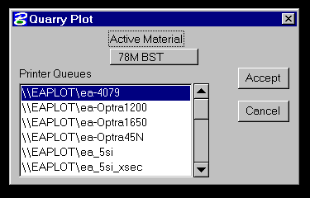
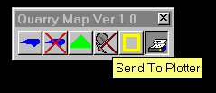
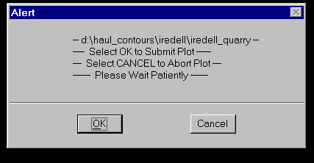
Once the equal cost contours for a material type are generated they can be plotted by using the sixth button (Send to Plotter) on the Quarry Map tool bar. When this tool is selected the Quarry Plot dialog will appear. As with most other tools this dialog allows the active material to be changed. Once the active material is set, a printer queue should be selected from the lower pane of the dialog box. To select a printer queue left mouse click on the queue name, it will highlight indicating it has been selected. After the queue is selected, click on the ACCEPT button to proceed with submitting the plot or click CANCEL to abort the plot. If the ACCEPT button is selected an Alert box will display giving the name of the file to be plotted and the last opportunity to abort the plot submission. If the OK button is selected the plot process will begin. It may take a minute or two to submit the plot so wait patiently. Once the plot is submitted an information box will display showing PLOT SENT SUCCESSFULLY. Click on the OK button to dismiss the information box.
All plots are scaled and rotated so they will fit on an 11”x17” size sheet at the maximum scale. If the plot is submitted to a black and white plotter the equal cost contour areas will be gray-scaled based on its color (provided the plotter is capable of doing filled shapes). If a color plotter is selected the contour areas will be color-coded but there may be some variance between screen color and plot color. In either event the color shading will be overlaid with the county mapping and the quarry locations. If the shapes cover the county mapping and the quarry locations, make sure the Iplot pen table named qmap.tbl is located in the NCDOT workspace directory. Also note the computer must have the MicroStation Iplot software loaded in order for this tool to function correctly. It will NOT work with MicroStation plotting.
Plots may be manually submitted using IPLOT. If this method is used, the user is responsible for selecting the paper size, the scale, and attaching the “/NCDOT_MS_STDS/wsmod/metric/qmap.tbl” pen table before the plot is submitted. MicroStation plotting may be used, however there is no MicroStation Plotting pen table available to alter the plotted output so the end results will appear somewhat different.
REMOVE COLOR_CODED MAP (Remove Active Mapping)

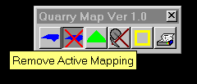
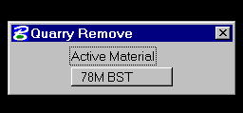
If the equal cost contours for a material type is to be deleted from the design file the second button (Remove Active Mapping) on the Quarry Map tool bar is used. This tool will delete the equal cost contours for the active material without generating a new set of contours. The Place Map tool will automatically delete existing contours of the material type before new ones are generated. When this tool is selected the Quarry Remove dialog box is displayed and the MicroStation prompt will read REMOVE ACTIVE MAPPING>SELECT VIEW. This dialog may be used to change the active material before the color-coded map is deleted. The map for the material type displayed on the face of the active material button will be deleted from the design file. Once the material type is set place a data point in the view to delete the equal cost contour mapping. If deleted contour mapping is to be restored use the MicroStation EDIT>UNDO function or perform the Place Map function.

QUESTIONS or COMMENTS

If there are questions or problems with the Quarry Map program please contact the Engineering Technology Systems Unit of NCDOT. Our address is
Engineering Technology Systems Unit
1020 Birch Ridge Drive
Raleigh, NC 27610
Please ask for
Kent Sanders 919-250-4177 ext. 285 KentSanders@dot.state.nc.us
Pat Holbrook 919-250-4177 ext. 245 PHolbrook@dot.state.nc.us

