Limits Of Construction

Activation of Tool

- The user may access the Limits of Construction tool by either the Cross Section dialog box or the pull down Applications>Geopak Road>Cross Sections>Limits of Construction.
- You will have ability to create a specific run for an alignment if the project was opened using Project Manager.
- General procedure is to open the tool while in the cross section file. Basic operation of the tool includes drawing the cut, fill, and transition lines in a predefined location or design file, usually a slope stake file that has been created as a Roadway User. It is best to run this operation as a Roadway User to insure proper level symbology.

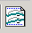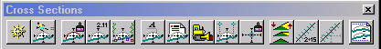

Limits of Construction Dialog Box

1.) While in the Cross Section file select the Limits of Construction icon.

The Limit of Construction dialog box will open reading information from the Project Manager and the Cross Section design file. The job number, chain, and begin and end stations are automatically read. A default Tolerance value of 0.75 is also entered. If Limits of Construction is to be computed for a specific range the user has the option to enter beginning and ending stations.

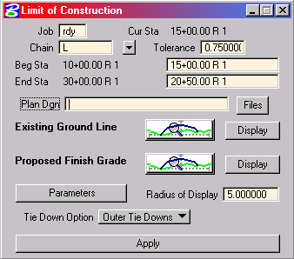

2.) Select the plan file to place the Limits of Construction Lines.

Just below the station ranges is the Plan Dgn field, containing the name of the plan view design file wherein the limits are to be drawn. Select files and path to a previously created design file. The design file would have been created using the Design File Generator to insure proper naming convention.

Selecting Search Criteria

3.) Use the wysiwyg tabs to define the existing and proposed symbology.
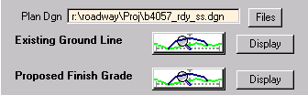

The Existing Ground Line and the Proposed Finish Grade may be defined using the WYSIWYG dialog buttons. Levels used are Exist XS Ground Line for the existing ground and Prop XS Finish Grade Earthwork and Prop XS Subgrade Earthwork for the Proposed Finish Grade. A rule of thumb to keep from getting error messages is to have the Proposed Finish Grade tie to the Existing Ground without break from the left to the right side of the cross section. Note: Close boxes by selecting the x in the corner to make selections effective.
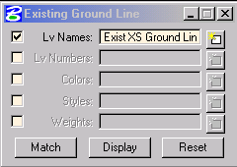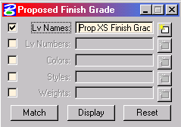

Set Slope Stake Symbology

4.) Set the symbology of the slope stake lines to be placed into the plan dgn.

To set the symbology of the plan dgn select the Parameters push button on the dialog. To set the Tie Down Option select Outer Tie Downs.

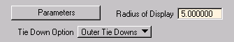

5.) Set the Plot Parameters for Construction dialog box.
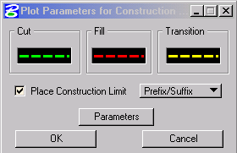

To set the symbology of the Cut, Fill, and Transition lines double click in the WYSIWYG box and set the levels to Prop SS Cut Line, Prop Fill Line, and Prop SS Transition Line accordingly. Be sure to set the symbology by level. To have the Limit of Construction tool also draw the C’s and F’s for cut and fill you must enable the Place Construction Limit with the option of Prefix/Suffix.

6.) Set Plot Parameters for Labels.

The Plot Parameters for Labels can now be set. To have C’s and F’s drawn relative to the slope stake line set the parameters as shown below.

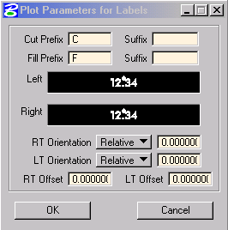

7.) Set the symbology of the labels.

To set the plot parameters of the labels double click the WYSIWYG boxes for both the left and right and set the symbology as shown below.

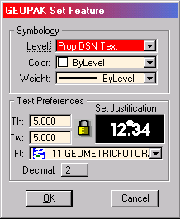
After all settings have been made close all dialogs that set the symbology or parameters by backing out hitting the OK button.

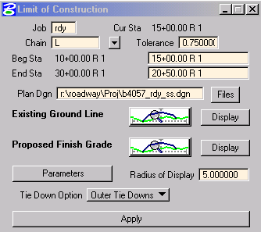8.) Select the apply button to place Construction Limit Lines.

The process will push you into the plan dgn file.

