TIN FILE CADD IMPORT FOR NATURAL ENVIRONMENT UNIT

- Go to the (s) drive under Engineering\DTM_contour. Copy the file english3d_contour to your Project folder files. This file will be used to import your GPS points and your Tin file.

Opening Microstation as an NEU User and Activating Geopak

1) Opening the Microstation file and activating Geopak Road.

It is necessary to open the Microstation file as a NEU User. The NEU user has all of the necessary levels that correspond to the microstation files. This will ensure proper level symbology without user input. The NEU User also has full access to the NCMAP menu. Simply double click the file and select the NEU as the available Workspace. It is highly recommended not to open Microstation any other way besides double clicking the file in Windows Explorer. This that ensures all necessary configuration files are loaded in the background.

It may also be necessary to activate Geopak if this is the first time it is opened. After Geopak has been activated the user may use the pulldown menu to activate Geopak Road, to Geopak Road Tools. (See Figure 1). In Geopak Road Tools the user will
click on Geopak DTM Surface Tool icon. This will open a new toolbox. (See Figure 2)

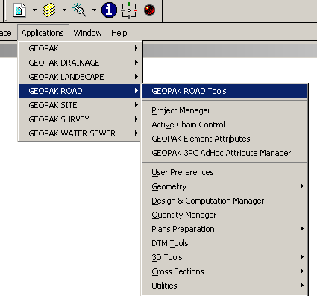

TIN FILE CADD IMPORT FOR NATURAL ENVIRONMENT UNIT (CONT.)

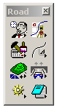 Figure 1. Figure 2.
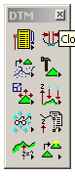
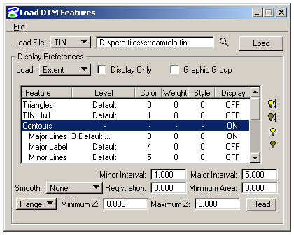Click on the DTM Feature icon, go to Load and locate your Tin. file Here you can adjust your Contours display to show major or minor lines by turning off or on. Also you can adjust the Interval.

