GEOPAK IMPORT ASCII for the NATURAL ENVIRONMENT UNIT

Folder Setup

1) Create Project Folder Structure.

- This set of instructions will recommend a Project Directory structure assuming points will be imported in the directory structure Pathfinder Office creates.
- 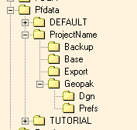The user should create a Geopak folder directly under the project folder. Under the Geopak folder the user also should create a Dgn and a Prefs folder. The Dgn folder will have the project Microstation file in which Geopak will import the ASCII points. The Prefs folder will have the Environmental.sdp file, which is the unit’s Geopak Survey preference file. This file in the future will probably move to the Unit’s workspace folder when it is published. It is also important to note other folders will be created in the folder structure during the importing process.

Opening Microstation as an Location User and Activating Geopak

2) Opening the Microstation file in the Dgn folder and activating Geopak Survey.

It is necessary to open the Microstation file as a Location user. The Location user has all of the necessary levels that correspond to the Pcodes. This will ensure proper level symbology without user input. The Location User also has full access to the NCMAP menu. Simply double click the file and select the Location as the available Workspace. It is highly recommended not to open Microstation any other way besides double clicking the file in Windows Explorer. This ensures all necessary configuration files are loaded in the background.

It may also be necessary to activate Geopak if this is the first time it is opened. After Geopak has been activated the user may use the pulldown menu to activate Geopak Survey.

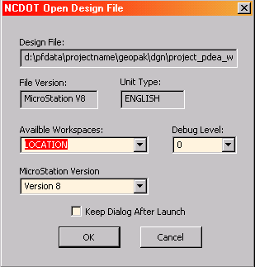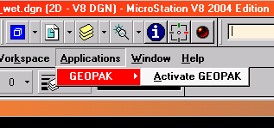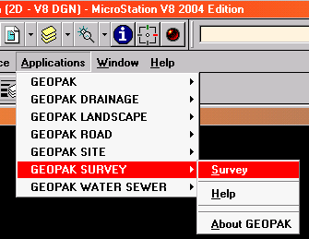

Opening Microstation Activating Geopak Survey

Geopak Survey and selecting the Project Preferences

3.) Select the Project pulldown menu and select preferences.

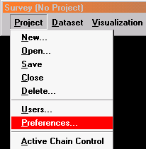By selecting the Preferences in the Project pulldown the user may path to the Unit Preferences , Environmental.sdp, found in the Pfdata\Project\Geopak\Prefs folder. The intention of the software is to copy the unit preferences and make them the project preference.

Selecting the Preferences will activate the Default Preferences dialog Box. By selecting the Default pulldown menu the user may path to the unit preference. (Environmental.sdp)

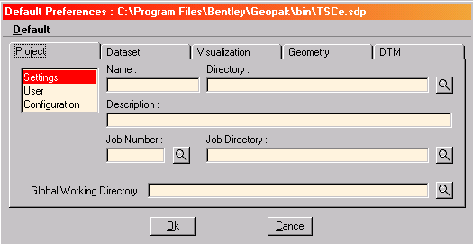

After selecting the unit survey preference file (Environmental.sdp) the user must select the Job Directory magnifying glass and path to the Pfdata\project\geopak folder. This will force any folders created by Geopak automatically to be placed in the Geopak folder.

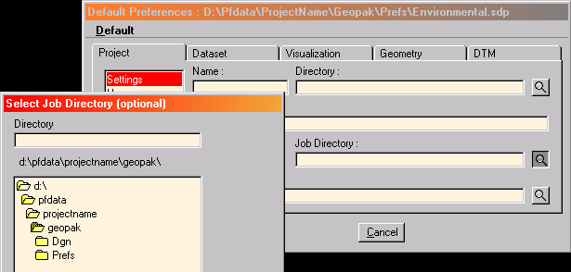

After the Geopak folder has been pathed out, select the OK button on the Default Preferences dialog box. The default preference of the project is now a copy of the unit preference.

Create the Geopak Survey Project

4.) Select the Project Pulldown menu from the Geopak Survey Menu and New and assign a project name and path to the Geopak folder. Assign a Job Number.

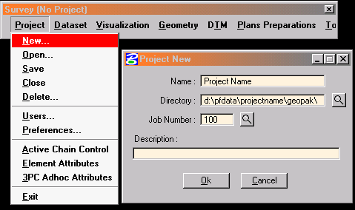

Note: Pathing to the Directory will insure all folders automatically created by Geopak will also be under the Geopak folder. Assigning the Job Number will create the *.GPK file. The *.GPK file is a binary file that is like a database file. The Job number may be 3 characters made up of alpha or numeric characters.

After the Project New dialog box has been filled out select the OK button.

Create the Geopak Survey Data

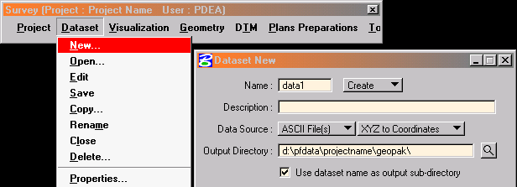5.) Create the data by selecting Data New and name the dataset and path to the geopak folder.

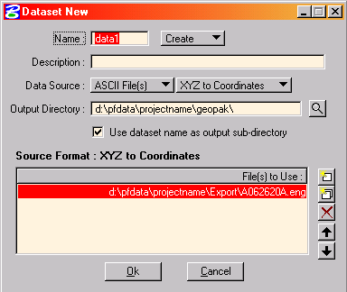After naming and pathing to the Output Directory the user must select the ASCII file exported during the Pathfinder Office session. By selecting the first icon on the New Dataset dialog box the user may path to the \Pfdata\Project\Export folder and selects the exported ASCII file. It may be necessary to change the List Files of Type to All Files to select the ASCII file. After all selections have been made select the OK button.

Processing the Data

6.) Process the points using the XYZ to coordinates dialog box.

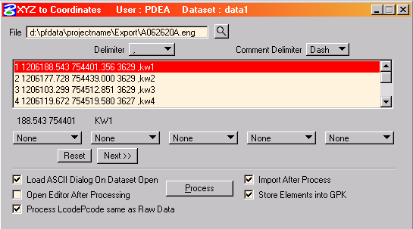Selecting the OK button in the Dataset New dialog will activate the XYZ to coordinates dialog box. Change the Delimiter button to space and then select the first line of the data in the interior of the dialog. This should line up the columns so the user may assign each column.
Shown below is the XYZ to Coordinates dialog box after the delimiter has been set to “Space” and also the first line of the data was selected. Notice the data lining up in columns under the “None” buttons.
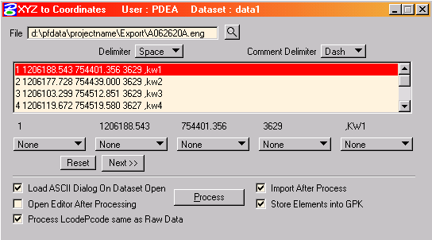

Each column can now be set to identify that column by selecting the “None” button and defining that column. The example shown will be “Pnum X Y Pcode None”. Notice the last column has a comma. This is necessary for any field text to be included with the imported data. It must also reside in the last column.

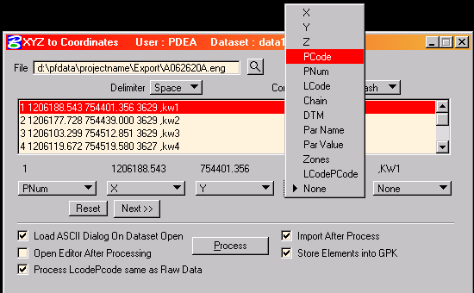

The process button may be pushed now that all of the columns have been identified.
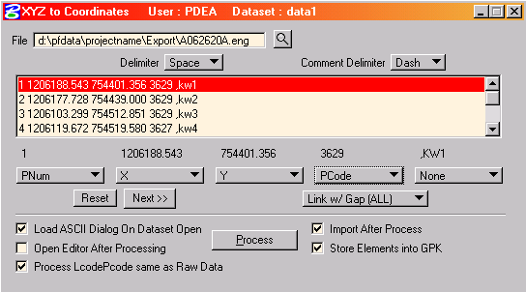
Some of the normal Alert messages may be as you see below. Take note of the message and simply select the OK button to continue processing.
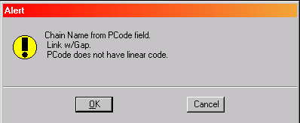

Pay particular attention to the Alert message below. This alert message pertains to how your Pcode is being read which effects the symbology in the Microstation file. In general the more errors the less likely the data will be drawn using the right symbology.
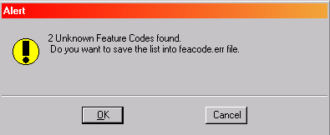
If your data was coded correctly in the field you should see that it was drawn using proper symbology to include levels and line styles.

Editing Data in GEOPAK

Individual points and Geopak chains may be edited while in a Geopak environment. Because of a known and reported bug in Geopak it may be necessary to open the Geopak SMD file to speed editing procedures. Simply go to Visualization and select Edit SMD file. The NCDOT SMD file is password protected, therefore a dialog box to enter the password will appear. Select cancel and the SMD dialog box will appear. Move this dialog box off to the side of your working area. This simple step will speed the editing process.

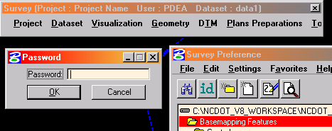

Points or chains may be edited by selecting Geometry and Points or Chains and Edit.

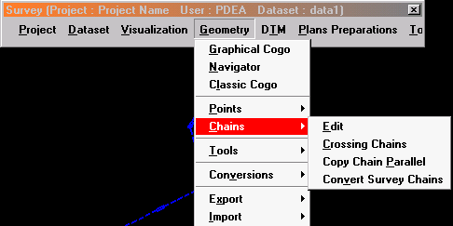

The most common reasons to edit data will probably be for either changing the symbology of a chain due to improper coding or inclusion or not including points in a chain. Below is the expanded version of the edit chain dialog box. To expand the chain edit dialog box click on the triangles on the right side of the box. The first icon on the box allows you to select the chain by data point and accepting in the Microstation design file. To change the chain feature enter the new feature number in the Feature slot. To add or take away numbers in the inclusion of the chain add or take away point numbers in the Point list box. Once changes have been made in the dialog box you must select the paint brush icon to update your Microstation file.
