Conversion Steps:

-Download a new workspace. --Workspace updates on your desk top.

-Create a new Directory on your D Drive called Countyname V8 Project (suggestion).
-Copy the seed file from:

C:\NCDOT_V8_WORKSPACE\GIS_Stds\English\gis_english_seed into this directory.

-Copy the Two County Files from the S: Drive ProdDev Directory.

-Rename the seed file to Countyname_PDD_temp.dgn

-Open the renamed seed file by double clicking. Once in the file:

-Click Files--- models: In the Models dialog box, change the description “countyname”to the county you are processing. You do this by clicking on the text to change until it highlights.

NOTE: You change Models by double clicking the desired model inside this box. We will discuss these further later on. Right now you should have the Road Network Model highlighted.

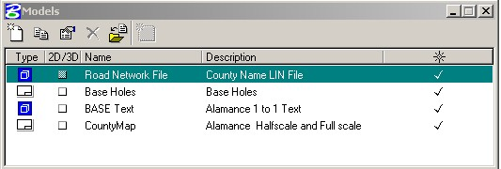

NOTE: V8 now gives us the entire path and file name at the top of the screen. It also shows us which model we have active.

-Attach the Old LIN file to the Model called “Road Network File”. Attachment Method is Coincident World.

File – Reference – tools – attach

FYI
-----------------------------------------------------------------------------------------------------------

Sets the view of the model being attached
Interactive- Opens the Reference Attachment Settings Dialog box for each file selected.
Coincident- Aligns the references with regard to design plane coordinates only.
Coincident world – Aligns the references with the active model with regard to both Global Origin and design plane coordinates.
-----------------------------------------------------------------------------------------------------------

-Make sure all levels are on in the reference file.
In the reference file dialog box – go to tools – settings - Level display (at the bottom) This brings up the level display dialog box.

NOTE: The levels that appear in the right area of the box, belong to the file name that is highlighted in the left area. You will have to pay attention to this when we start working with many reference files and Models. The model has the blue V8 icon while the reference file inside that model is a white B.

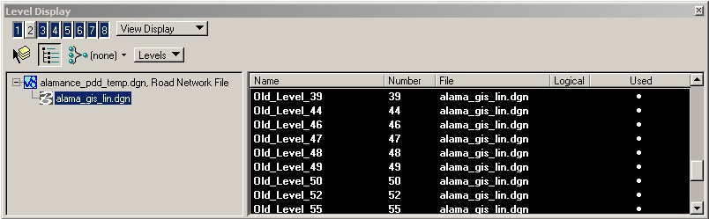

Change between these two files by clicking on the icon. Notice how the level names change.

Put your cursor inside the area on the right and “right click”. Click on the “All On” tab. This will turn all the levels on in the reference file.

NOTE: The level manager box will not dock like the other boxes. You have to hold the Ctrl key down in order to move this box off the viewing area. *@!#$%(*^ . I hope they fix this later.

Make sure live nesting is OFF

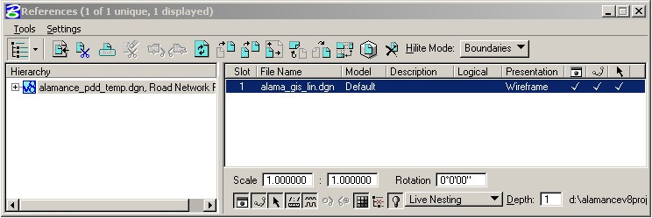

NOTE:
We will be working with nested reference files later. It means that we would get an attachment to an attachment. If Alamance had an attached reference file we could bring that in also. We can use this to our advantage by cutting down on the amount of reference files attached to the plotting area.

Go back to the reference file dialog box and merge it into the active file. Highlight the file and go to tools – merge into master.

ReMapping

We now have a file that is in English working Units. Survey feet and inches.

FYI

Difference between Survey Feet and the standard foot is described below. We are using the survey foot in our files. This is used through out DOT.

A coordinate system in meters may be converted to a coordinate system in ‘U.S. survey feet’ by scaling the system to a scale factor of 3.28083333333. An exact conversion can be accomplished by multiplying meters by the fraction 3937/1200.

The foot is one-third of the Imperial standard yard, which is defined to be 0.9144 meters, exactly. Thus the foot is defined as 0.3048 meters, exactly.

Our files are now projected into state plane standard projection with the NAD 83 datum. This is a “Lambert Confomal Conic” Projection.

Go to file Save as.
Change the name Countyname_PDD.dgn. (In other words take off the TEMP part).
Go to OPTIONS under the OK or Cancel Button.
There is a dialog box with three tabs: Remap References and Filter. Go to REMAP
Use the magnifying glass to browse for the Remapper CVS file.

You will find it:
C:\NCDOT_V8_WORKSPACE\NCDOT_STDS\Standards\dgnlib\LINremapper.

Under the Remap tab click Apply Level Mapping on.
Under References Tab -Levels from view None
- Self attachments Omit
- External Attachments Omit
- Copy Levels During Merge (Always)
- All other buttons OFF

Under Filters
-Geometry (Everything)
Leave everything else the same.

Click on the OK Button. (and then the other OK) and hold your breath

To see how the Remapper worked:

Click on the B in the Upper Left-hand corner of view one and click on Level display.

Click on the used portion of the Level display dialog box. This will bunch all the used levels together. Click it again and they will appear at the top of the list.

Anything on Old_Level * is from the old LIN file and needs to be placed on the correct level. We will need to check the other levels. Leveling is very important in V8.

Changing levels is the same as Microstation J. The level names are longer. It is helpful if you learn to create your own filters. Many have already been done for you. You can see them if you change “levels” to “filters” in the level display box.

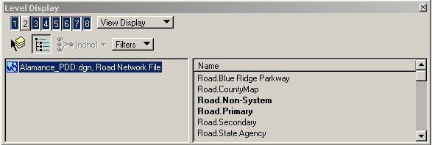

To use a filter click on the one you want and then click in the view. See what happens. Try clicking another one.
The procedure, to change a level in V8, is the same as “J’. Some of the dialog options are different. You will do a batch select using what ever tool you are use to using. I like “Select by attributes”. Under tool the select by element saves time. These tool work the same as “J’.
The “Change Element Attributes”, tool, however, is not the same. There is use active Attributes button. This button gives us the option of using the active Attributes set at the file level. Or make on the fly changes.

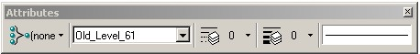

BY Level:
By using the By Level option you don’t have to think about what the color. Weight, or Linestyle should be. These defaults are set in the DGNLib. The advantage to this is if we all decide that we don’t like the color of Lakes, for example, we make a global change at the Library level, which in turn changes all the files.

To change the levels you first have to select the correct level to put it on. This is the drawback to having so many levels to choose from. You can use the level display, double click the correct level making it the active level. If the level name is in bold print in the level display it is occupied.

NOTE:

You can not create or delete levels

An asterisk (*) appears in the Level Manager for a library level or an attachment level, when one or more attributes are modified so it is different from its source. This will need to be corrected.

Make sure all levels are correct.

The easiest thing is to make sure all levels are correct in the “J” file. Please drop complex status on all road levels. NOT BOUNDARIES.

During the remapper process levels had to be bunched together because of the level limitations in “J”. At this point we must check and re-level everything in the new V8 file. Here it is step by step.

Change the Model to Road Network

Change the 2 lane road line style “GIS Rds Und Lan 2” to style 0.

Non-system roads go to level Exist Road Non-System Type 51 Color by-level wt=1

Non-System text goes to level Exist Road Non-System type 51 label color by-level

Secondary Roads change weight to 7
-Electrical Transmission Lines -turn off Exist utilities Electrical Transmission Line – If the yellow lines go away, then they are on the correct level. We will change the scale later.
Turn things off as you go along. This helps uncluttered.
Non-System Roads
Non system Road Labels

.

Next change all the 4 lane undivided roads.

To the new PDD Line Style PDD 4 Lane UND
Some Counties have the 3 Lane undivided style in them. These will need to be changed as well.

Transmission lines as well.

Railroads change scale and weight to 3.
change linestyle PDD Railroad Mainline.
Change the Sidings to: PDD Railroad Siding.
Change Leader Lines to PDD Leader.
Change Type 10 to PDD Road Type 10 etc..

By doing this we have scaled the linestyles so they will be the correct scale, of 1, for a Plot of 5280 to 1.

Note:
The reference files in the design sheets have a button that tells Microstation not to scale the Linestyles in the inset files.

Hydrographics

Rivers and Lakes are not consistently leveled in the V7 files. Do the best you can putting Lakes on the Lake level etc…

Buffer lines should go like this: The one nearest the outside Lake (for example) line should be one weight down from the Lake out line. These will be solid lines. The next one should be one more weight down etc… until you get to zero than make all the rest weight Zero. The Offset is 75. Then 112 then 168 then 252 …

Items we will have to place by hand:
Cell replacer will only replace cells. Any of the old text font symbols will have to be done by
Delete and replace all circles.
Symbols that appear on the Base ,Insets and Base Holes. Place in the County Map Plot Sheets and the Road Network File.
Replace:
Community and town symbols with Map Preparation County Community Circle.

Shields
Shields are set up for inset scale. Shields have their own cell library.
S:\GIS-ProdDesign\V8workspace\CELL_LIBRARY\GIS_PDD_Shields.
They are larger than they were. They are a cell with an enter data field. The Font is a text style. Unlike before, all the shields are the same size and the text size is changed to fit the shield. They will be placed in the file everywhere they need to be. We will place the larger ones for the base map in the sheet file. Base scale shields are never needed for a division map. Delete the old shields and text as you go along.
To place the shields in the base file change the active scale to .25. Before you place the shield make sure there is nothing checked. We will not use relative or interactive or true scale. They can also be placed on top of the lines.
Keep in mind when placing the shields that they will show up in the insets. Check their positioning on the first test plot.

The text can be edited.

Example of editing the enter data fields to make the text line up right.

If you need a NC Shield with three “two digit” numbers in it then chose one that is close to what you want. Chose Label six. It has a BUS field in it plus the two other numbers. Place the numbers in the fields as usual. Edit the “three digit” BUS at the top. Go to edit text, click on the piece of text you want to edit. You will see something like this:
<< 49>>. Delete the space between the <<>> leaving only the digits. (<<49>>). This should line the text up.

City Limits

The City Limits will look like the original hand drawn maps.
Procedure:
Old City limits still go on the Old City Limit levels.
Specifically, Exist Boundary Political City Limit Old and
Exist Boundary Political City Limit Old Hole
When replacing the old with the new.
Delete the old City Limits and move the new ones on to Exist Boundary Political City Limits New and Exist Boundary Political City Limits New Hole

City Limit Buffer. We are going re-symbolize the city limits to look like the old county maps. To do this we must copy the new City Limits to a buffer level and change their appearance.

Turn off all levels except the new City Limits. Select or place a fence around them.

Key-in: Level Element Copy Map Preparation Boundary City Limit Buffer Line

Data point to accept

To copy elements from one level to another level using a key-in

- Key in LEVEL ELEMENT COPY [dest: level -spec2] level-spec1.
Copies all elements on “level-spec1” to specified destination “levell-spec2”. The destination level specification is optional. If it is not specified, then the elements are copied to the “Default” level.

City Names and Circles

CELLS
There are two cells. One represents community, towns and cities. The other one is for County Seats.
LEVELS
These two cells will be placed on a selection of three levels, representing city names. One level is for communities. One level is for cities and towns. Lastly, one level for County Seats.

Exist Civil Demographics City CELL
Exist Civil Demographics Community CELL
Exist Civil Demographics County Seat CELL

TEXT LEVELS AND SIZES

City demographics are represented by text sizes and Palation Linotype font.

Insets:
Community names,
Text size 275 ,Bold, Italics.
The level is:
Exist Civil Demographics Community Label

Mountain Summit Text: Tx= 375, Palentonio, Base TX = 750.

