Install IBM MQ Series 8.0.0.4 Client

Run setup.exe as Administrator
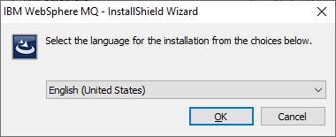

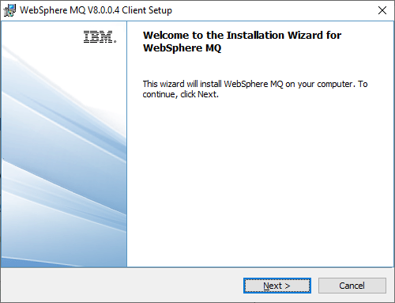

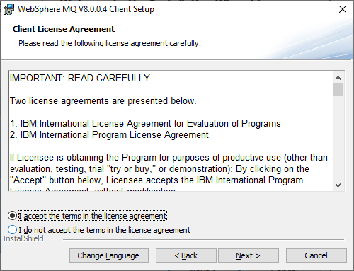

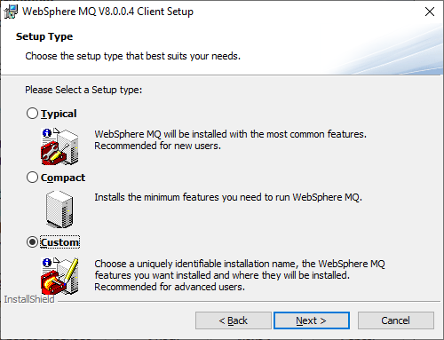
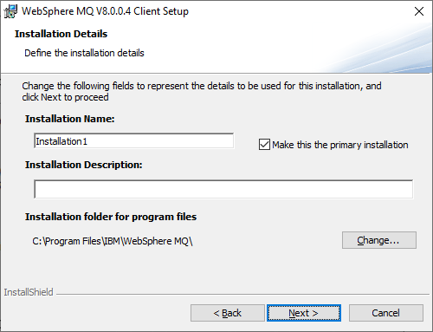
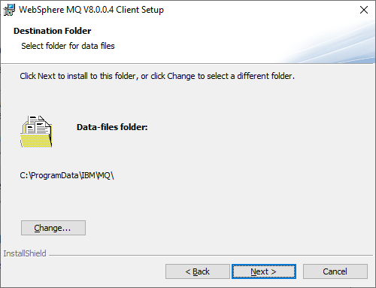
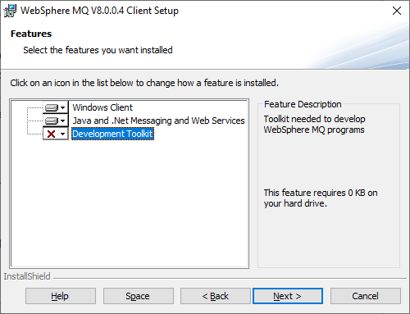

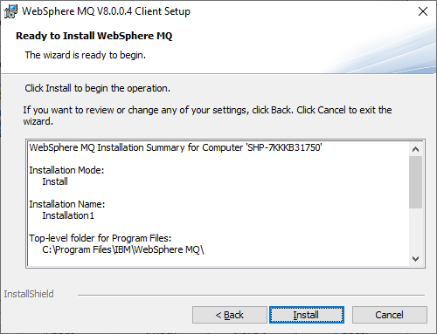
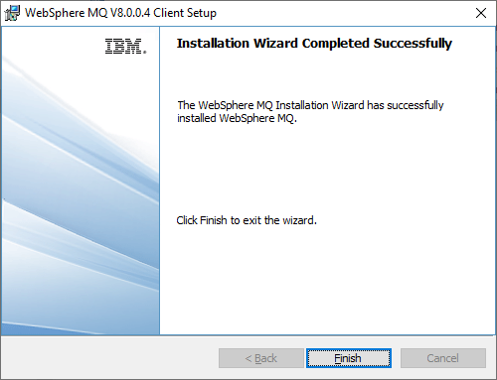

*** NOTE ***
https://www-01.ibm.com/support/docview.wss?uid=swg1IT12126

Need to re-register MQAX200.DLL

C:\Windows\SysWOW64>regsvr32 "C:\Program Files\IBM\WebSphere MQ\bin\mqax200.dll"

Otherwise cant find the active-x component at all.

