Barcode installation

Prerequisites
- Requires Microsoft .Net Framework 3.5 (which requires at least Windows XP)

Installation

Location of files is on fueltacs ftp website:

\Archive\Old Installs\Download\TSU Only\Release10\Barcode

Download the files to a temporary directory.
Rename BCSetup.exe to BCSetup.msi ( this is a windows installer file )
Run setup.exe, or right-click on the .msi file and select “Install”.

The installation will start as shown below:
Click “Next”

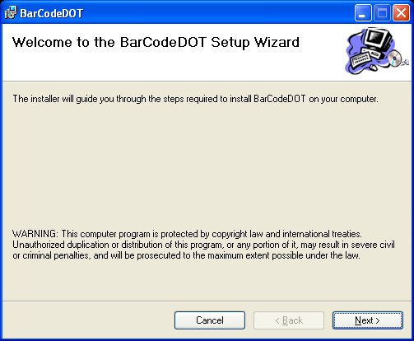

Leave install directory “as is” or select new install directory.
The default install directory is C:\Program Files\NCDOT\BarCodeDOT\

Leave selection of users as “Everyone”.

Click “Next”.

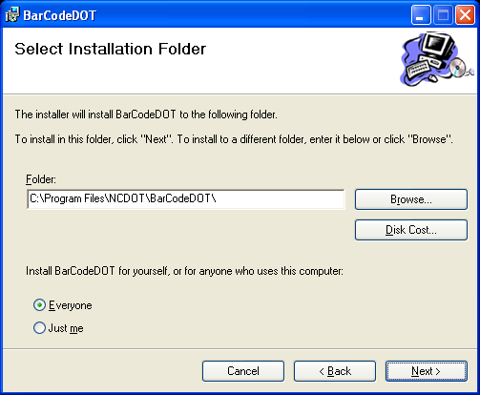

Click “Next”.

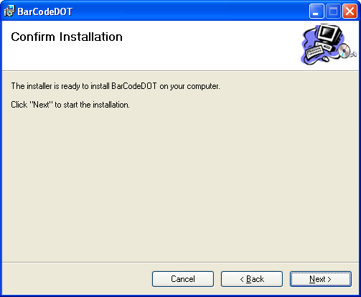

The installation will proceed.
When complete, the barcode application is installed.

Note: barcode is installed in the “Startup” folder for “All users”.
i.e. C:\Documents and Settings\All Users\Start Menu\Programs\Startup
You must either logoff/login or reboot to activate the barcode application.

If the barcode application is not required for the user, it can be removed and the application will not autostart on system startup.

