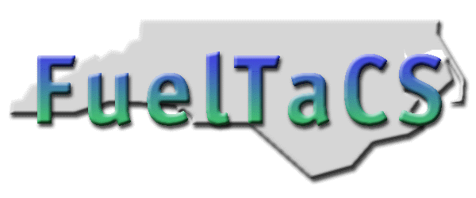
DMVFuelTaCSDotNet Application Installation

NCDIT Transportation - DMV Systems – Enforcement

Table of Contents
Installation of DMVFuelTaCSDotNet Application 2
Prerequisites: 2
DMVFuelTaCSDotNet Installation 3
Uninstall DMVFuelTaCSDotNet 11
Reinstall DMVFuelTaCSDotNet 12
DMVFuelTaCSDotNet Barcode Installation 20
DMVFuelTaCSDotNet GPS Installation 20

Installation of DMVFuelTaCSDotNet Application

Prerequisites:

- Operating system : Windows 10

- .Net Framework version 4.0

- Appropriate Admin Rights

- Phase 2 BarCodeEngine should be closed.

DMVFuelTaCSDotNet Installation
- Install files on your local hard drive.
- Open this URL/Link https://xfer.services.ncdot.gov/fueltacsftp/ in browser
- Go to this path :- /Archive/Old Installs/Download/FueltacsDotNet/DOR_Test
- Get to the latest build by date and time and click on it
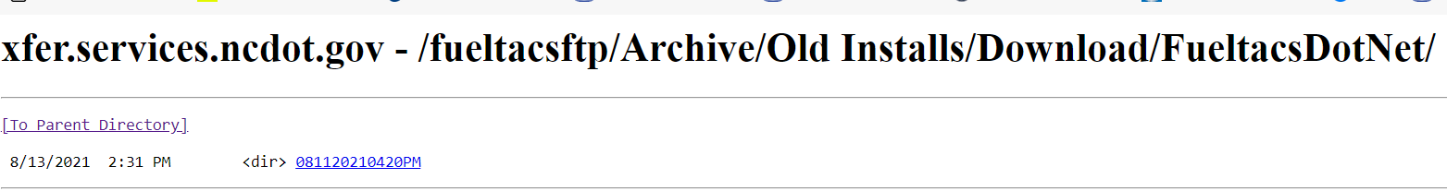

- Right click .Zip file and select ‘Save Target as’ and save on your local drive
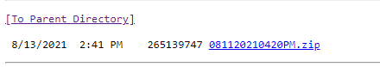
- Go to the location/folder on your local drive and extract the files from the .zip file
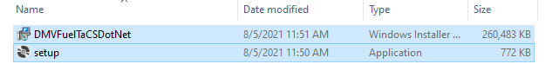

- Double click on setup.exe.

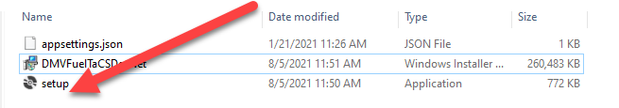

- Click Next on Welcome to the DMVFueltaCSDotNet Setup Wizard screen.

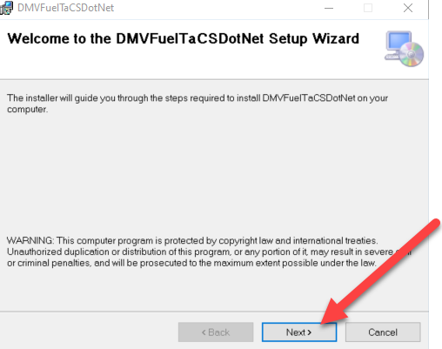

- Click Next on Select Installation Folder screen. Make sure that Everyone radio button is selected.
NOTE: The system will select default folder for installation

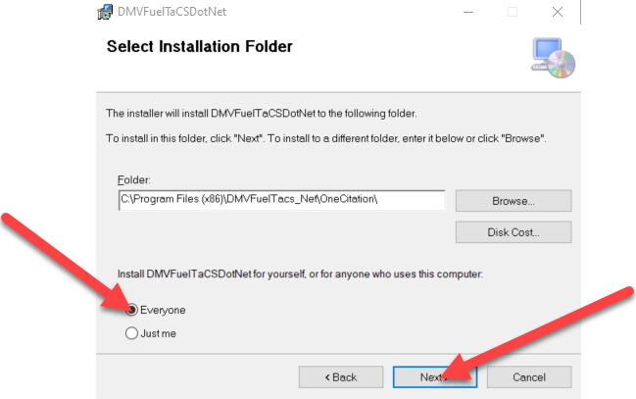

- Click Next on Confirm Installation screen.

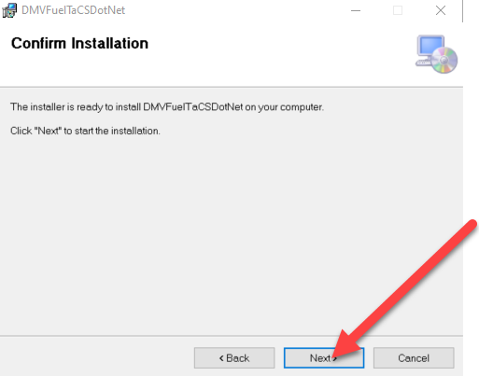

- Enter your admin credentials (If prompted)
- Click Close on Installation Complete screen.

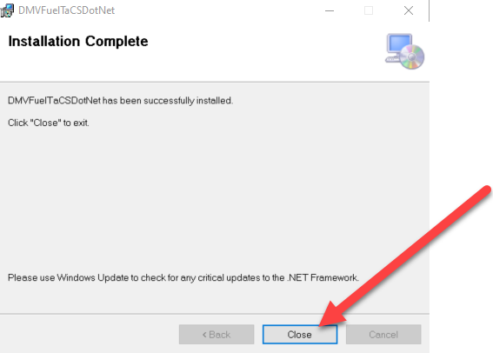

Application is installed successfully.

- The Users Group for the install directory must have full control. Required first time
Only.
- Go to C:\Program Files (x86)\DMVFuelTaCSDotNet
- Right click on DMVFuelTaCSDotNet folder
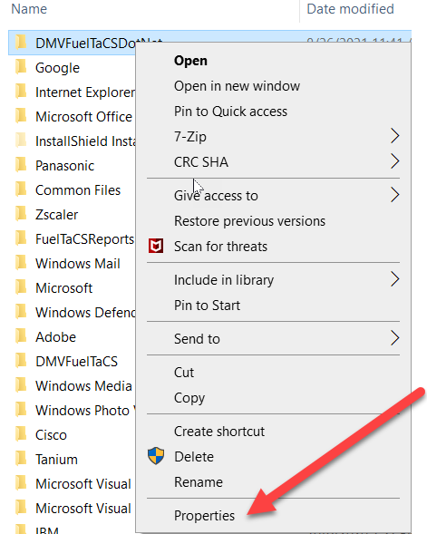

- Click Security. Select Users and click Edit. Check Full Control and Modify checkboxes if not checked and click apply on Permissions for DMVFueltaCSDotnet.
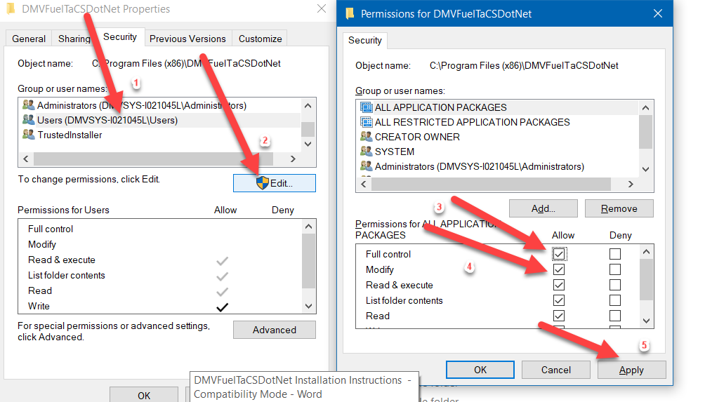

C

lick the FuelTaCS icon on your desktop to launch the application.

NOTE: If you do not have a shortcut icon on your desktop, you can launch DMVFuelTaCSDotNet by selecting Start >OneCitation > FuelTaCSClient

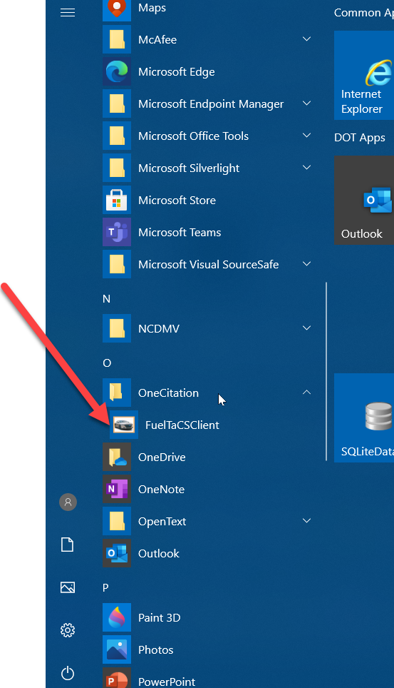
- If you encounter following error, click OK and restart your machine. Make sure you click only one time on FueltaCSClient.

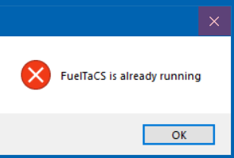

Uninstall DMVFuelTaCSDotNet

- Open Control Panel
- Select Programs and Features
- Right click on “DMVFuelTaCSDotNet”
- Select Uninstall

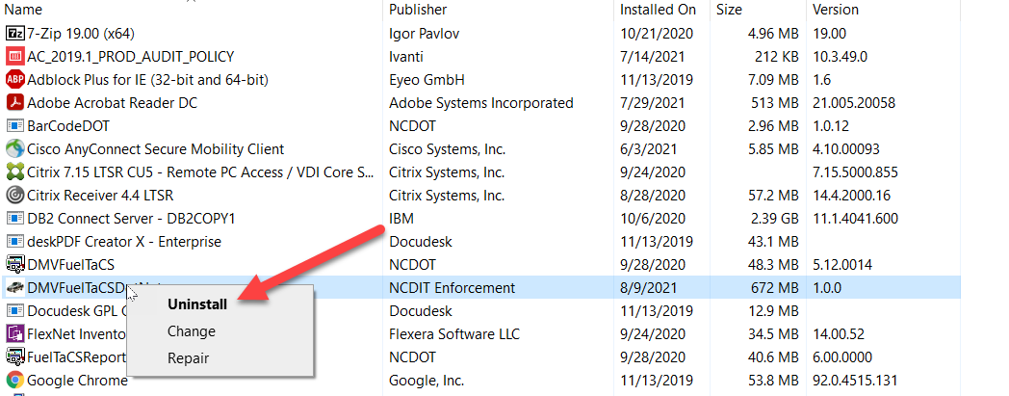

- Click ‘Yes’ for displayed question.

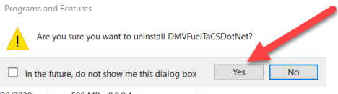

- Enter admin credentials when prompted

- Let uninstall complete

Reinstall DMVFuelTaCSDotNet
- Install files on your local hard drive.
- Open this URL/Link https://xfer.services.ncdot.gov/fueltacsftp/ in browser
- Go to this path :- /Archive/Old Installs/Download/FueltacsDotNet/
- Get to the latest build by date and time and click on it

- Right click .Zip file and select ‘Save Target as’ and save on your local drive.
- Go to the location/folder on your local drive and extract the files from the .zip file

- If system displays ‘Replace or Skip Files’ message. Click ‘Replace the files in the destination’ option to copy the files

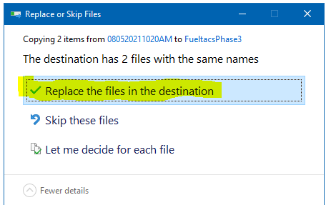

- Open Control Panel

- Select Programs and Features

- Right click on “DMVFuelTaCSDotNet”

- Select Uninstall

- Click ‘Yes’ for displayed question.

- Enter admin credentials (if prompted)

- Let uninstall complete

- Go to the location where install files were earlier copied.

- Double click on setup.exe.

- If system displays message regarding an unrecognized app, Click on More info and select Run anyway.

- Click Next on Welcome to the DMVFueltaCSDotNet Setup Wizard screen.

- Click Next on Select Installation Folder screen. Make sure that Everyone radio button is selected.
NOTE: The system will select default folder for installation

- Click Next on Confirm Installation screen.

- Enter your admin credentials (If prompted)
- Click Close on Installation Complete screen.

- Application is installed successfully.
- Double-click the FuelTaCS icon on your desktop to launch the application.

NOTE: If you do not have a shortcut icon on your desktop, you can launch FuelTaCS by selecting Start > OneCitation > FuelTaCSClient

- If you encounter following error, click OK and restart your machine. Make sure you click only one time on FueltaCSClient.

DMVFuelTaCSDotNet Barcode Installation
Pre req:

- Shut down FuelTaCS Ph-2.
- Barcode engine executable is closed.
Right click on Barcode engine executable and click on Close application.
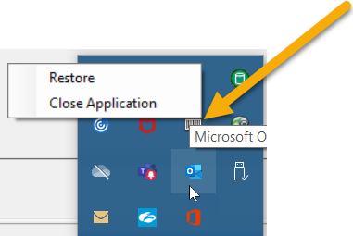

- Make note of the port from device manager it was installed on / i.e., COM8
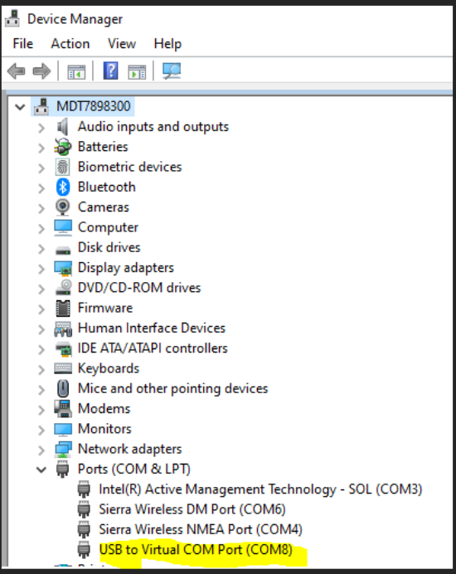
- Update config file with COM
<add key="BarCodePort" value="VALUE NOTED IN STEP 2" />
<add key="RunBarCode" value="true" />

- Start Ph-3 application.

DMVFuelTaCSDotNet GPS Installation

Note:
There are settings that affect function of the GPS in the app.config (aka FuelTaCSClient.exe.config) file that are defaulted and may need to be adjusted for the GPS to work.
Only 1 of the GPS’s should be used at a time when running FT phase 3. The settings in the config file should be in reference to that GPS.

- Only 1 of the GPS’s should be used at a time when running FT phase 3.

Pre-req for using Internal GPS
- FZ-55 SHP laptop
- GPS viewer is not running.
- For the Internal GPS inspect the Device Manager: Driver is listed as: Sierra Wireless NMEA Port (COMx)

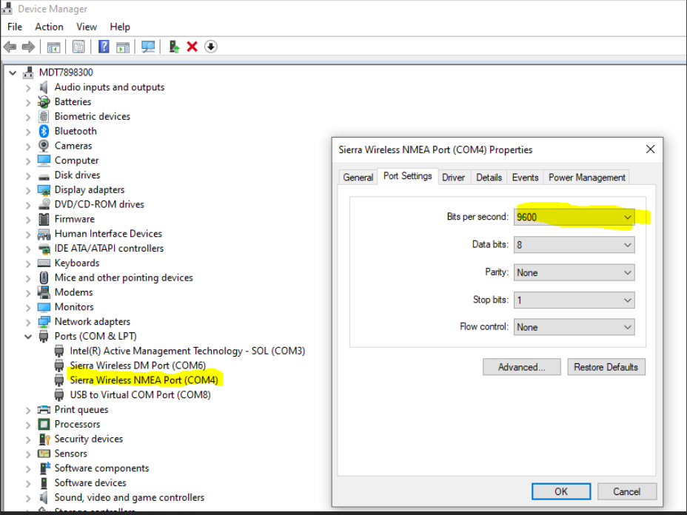

- Make note of COM and Bit Per second (Baud) values.
- Update CONFIG file settings
* <add key="GPSPort" value="COM4" />
* <add key="GPSBaud" value="9600" />

Pre-req for using GPS:BU353
- Franson GPSgate and GPS viewer are close,
- GPS-BU353 stick is inserted
- For BU353 inspect the Device Manager: Driver is listed as: The BU353 driver is listed as: Prolific USB-to-Serial Comm Port (COMx)
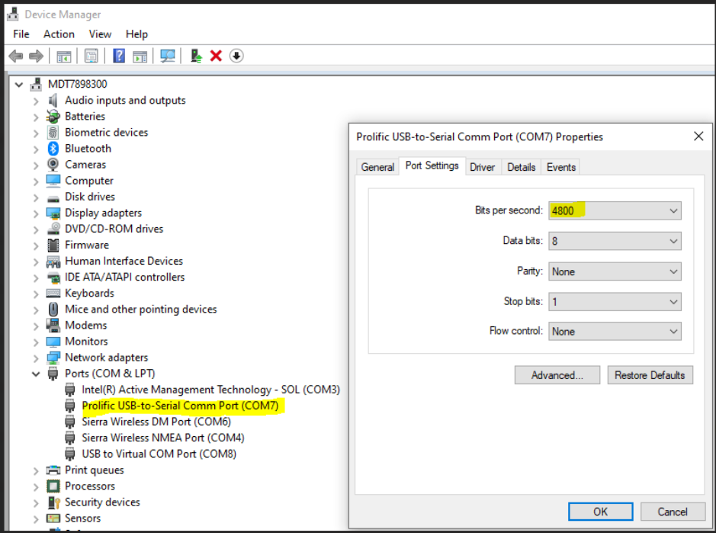
- Make note of COM and Bit Per second (Baud) values.
- Update CONFIG file settings
* <add key="GPSPort" value="COM7" />
* <add key="GPSBaud" value="4800" />

Pre req for Using GPS:18x
- FZ-55 SHP laptop.
- Garmin 18x USB stick is inserted.
- GPS viewer is not running.
- Using Franson find the port that is working

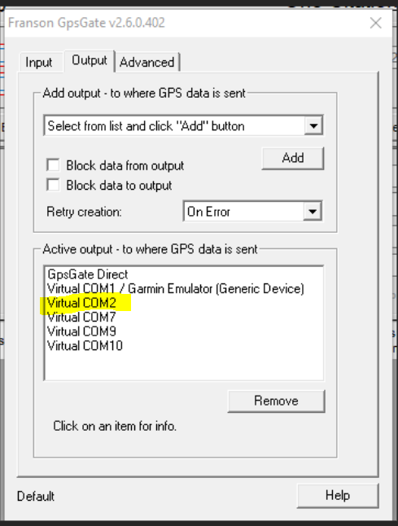
- Use the same port in Config file.
- The baud is 9600 for the 18x
<add key="GPSPort" value="COM2" />
<add key="GPSBaud" value="9600" />

