CUSTOMER_NAME
CUSTOMER_ADDR

Re: The following citation(s).

Number | Issue Date | Citation Type

Thank you for your payment of the assessment(s) listed above.

Your reciprocity has been restored and you may again enjoy the privilege of using the highways in North Carolina.

The State of North Carolina Administrative Code requires notification of this reciprocity reinstatement to the appropriate authority determined by the state in which your vehicle(s) was (were) registered for operation.

Sincerely,

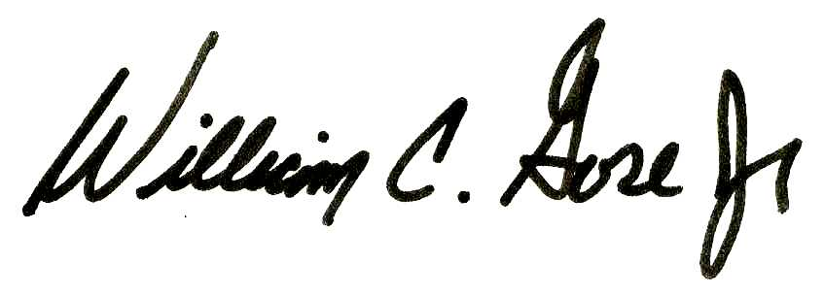

By: DMV_COMMISSIONER_NAME
Commissioner of Motor Vehicles

Dated this Dayth, day of Month, Year.

OOS_DMV_ADDRESS_HEADER
OOS_DMV_ADDR

Re: The following citation(s).

CUSTOMER_NAME
CUSTOMER_ADDR

VEHICLE_POWERUNIT_VIN_DESC VEHICLE_POWERUNIT_PLATE_DESC Year: VEH_PU_YEAR

Number | Issue Date | Citation Type

Thank you for your payment of the assessment(s) listed above.

Your reciprocity has been restored and you may again enjoy the privilege of using the highways in North Carolina.

The State of North Carolina Administrative Code requires notification of this reciprocity reinstatement to the appropriate authority determined by the state in which your vehicle(s) was (were) registered for operation.

Sincerely,

By: DMV_COMMISSIONER_NAME
Commissioner of Motor Vehicles

Dated this Dayth, day of Month, Year.

