CUSTOMER_NAME
CUSTOMER_ADDR

Re: RECIPROCITY SUSPENSION due to following citation(s).

Number | Issue Date | Due Amount | Citation Type
Total |  | RECIPROCITY_BALANCE_AMOUNT | *Total includes fines, penalties, late fees & interest due.

Acting under the authority vested in the North Carolina Division of Motor Vehicles’ Commissioner of Motor Vehicles and through the provisions set forth in the North Carolina General Statutes Chapter 20, Article 1A, you are hereby notified that your privilege to operate motor vehicles owned and leased by you within the boundaries of this State is hereby suspended indefinitely.

This suspension is due to the fact you have violated reciprocal agreements as provided in the above Chapter and Article to wit:

Failure to pay the North Carolina State Highway Patrol Motor Carrier Enforcement Administration Section, as well as, the NC DMV Fiscal Section the assessed amount of RECIPROCITY_BALANCE_AMOUNT.

Until full payment is received all vehicles owned and operated by you within North Carolina will be seized by the Highway Patrol. All revocations shall remain in place until all assessments, fines, late fees and interest have been satisfied. Also, statutorily required interest will continue to accrue on the assessment amount until satisfactory settlement of this account.

In order to satisfy this account, make payment by certified check or money order payable to the NCDMV Fiscal Section and mail to the following address:
.
NCDMV Fiscal Section
P.O. Box 29615
Raleigh, North Carolina 27626-0615

Please indicate the above referenced citation number(s) in any payment that you remit. Should you wish to pay this assessment through the use of a credit card, please contact the NCSHP Motor Carrier Administration Section and they will assist you. All inquiries regarding this assessment, including any payments, penalties, fines, late fees and interest, should also be directed to the NCSHP Motor Carrier Enforcement Administration Section at SHP_PHONE_NBR.

Your reciprocity may be restored upon satisfactory settlement of this account.

Witness my hand and official seal, this the CURRENT_DAYTH day of CURRENT_MONTH_NAME, CURRENT_YEAR

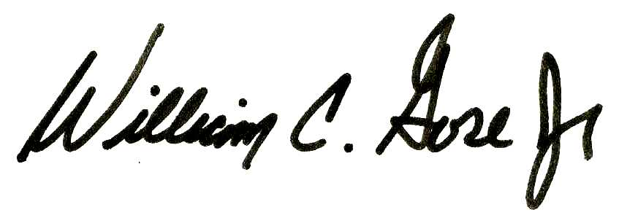

By: DMV_COMMISSIONER_NAME
Commissioner
N.C. Division of Motor Vehicles

CC: Director Vehicle Registration, NCDMV

OOS_DMV_ADDRESS_HEADER
OOS_DMV_ADDR

Re: RECIPROCITY SUSPENSION due to following citation(s).

CUSTOMER_NAME
CUSTOMER_ADDR

VEHICLE_POWERUNIT_VIN_DESC VEHICLE_POWERUNIT_PLATE_DESC Year: VEH_PU_YEAR

Number | Issue Date | Due Amount | Citation Type
Total |  | RECIPROCITY_BALANCE_AMOUNT | *Total includes fines, penalties, late fees & interest due.

Acting under the authority vested in the North Carolina Division of Motor Vehicles’ Commissioner of Motor Vehicles and through the provisions set forth in the North Carolina General Statutes Chapter 20, Article 1A, you are hereby notified that your privilege to operate motor vehicles owned and leased by you within the boundaries of this State is hereby suspended indefinitely.

This suspension is due to the fact you have violated reciprocal agreements as provided in the above Chapter and Article to wit:

Failure to pay the North Carolina State Highway Patrol Motor Carrier Enforcement Administration Section, as well as, the NC DMV Fiscal Section the assessed amount of RECIPROCITY_BALANCE_AMOUNT.

Until full payment is received all vehicles owned and operated by you within North Carolina will be seized by the Highway Patrol. All revocations shall remain in place until all assessments, fines, late fees and interest have been satisfied. Also, statutorily required interest will continue to accrue on the assessment amount until satisfactory settlement of this account.

In order to satisfy this account, make payment by certified check or money order payable to the NCDMV Fiscal Section and mail to the following address:
.
NCDMV Fiscal Section
P.O. Box 29615
Raleigh, North Carolina 27626-0615

Please indicate the above referenced citation number(s) in any payment that you remit. Should you wish to pay this assessment through the use of a credit card, please contact the NCSHP Motor Carrier Administration Section and they will assist you. All inquiries regarding this assessment, including any payments, penalties, fines, late fees and interest, should also be directed to the NCSHP Motor Carrier Enforcement Administration Section at SHP_PHONE_NUMBER.

Your reciprocity may be restored upon satisfactory settlement of this account.

Witness my hand and official seal, this the CURRENT_DAYTH day of CURRENT_MONTH_NAME, CURRENT_YEAR

By: DMV_COMMISSIONER_NAME
Commissioner
N.C. Division of Motor Vehicles

CC: Director Vehicle Registration, NCDMV

