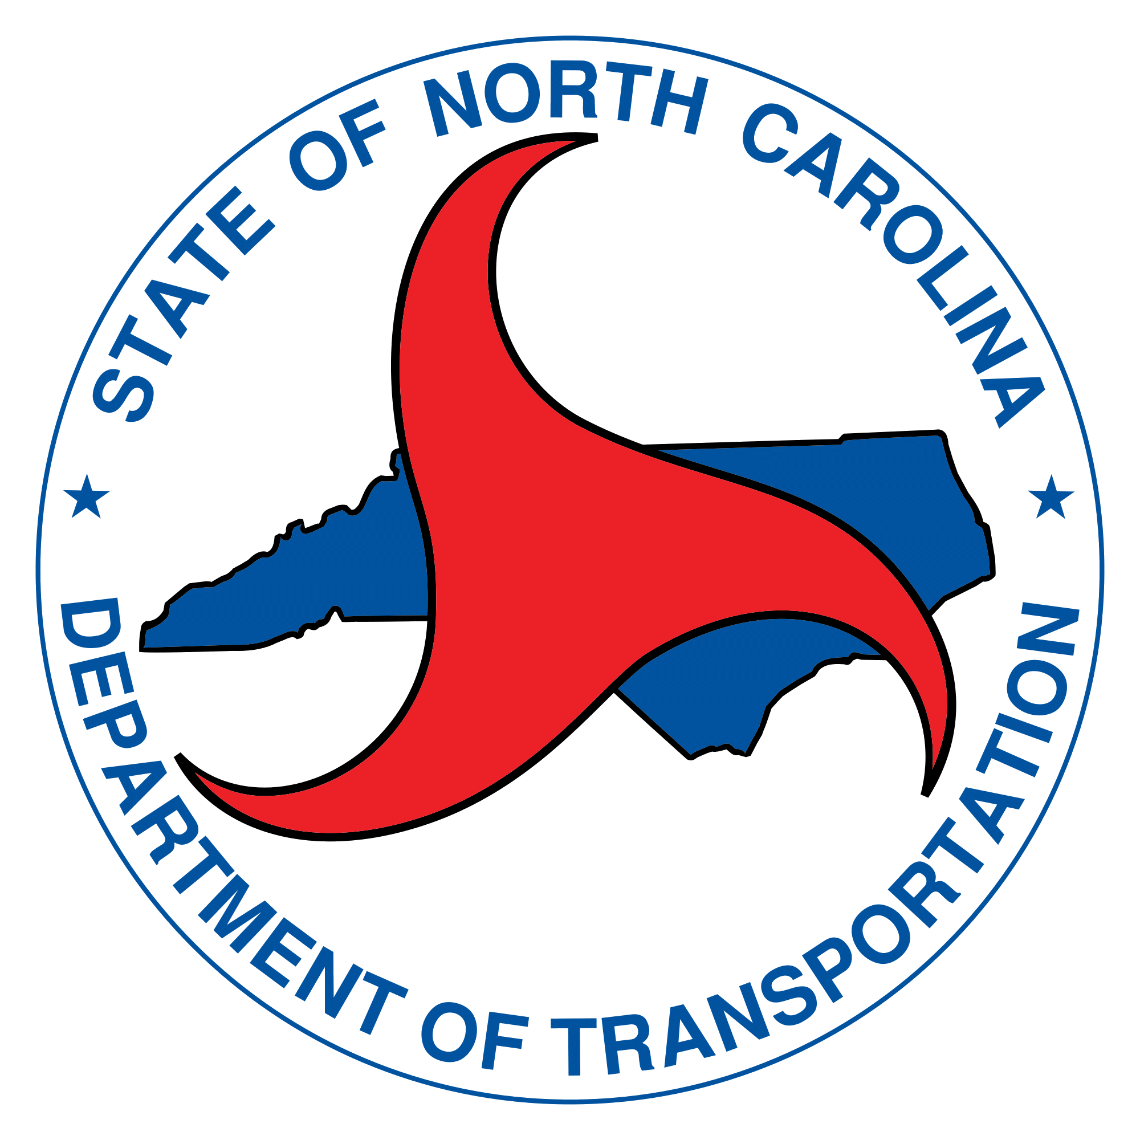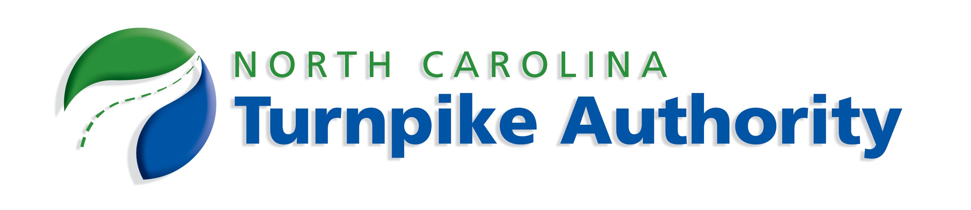

Mid-Currituck Bridge
Currituck County
STIP No. R-2576

Interagency Meeting Agenda
June 20, 2019
1:00 to 3:00 PM – NCDOT Structures Conference Room

Purpose: To update agencies on the project status since the prior meeting on 3/14/18 and to revisit prior project potential issues of concern relative to stormwater management, submerged aquatic vegetation, and fisheries moratorium for the project.

- Project Status Update
  - Previous Interagency Meeting – 3/14/18 (minutes attached)
  - Final EIS Reevaluation and Record of Decision
- Prior Potential Issues of Concern
  - Stormwater Management
  - Submerged Aquatic Vegetation
  - Fisheries Moratorium
- Permitting and Mitigation
- Next Steps

